

**Department of IT Development**

SYSTEM DEVELOPMENT LIFE CYCLE (SDLC) PLANNING

Third Revision

1st of June 2015

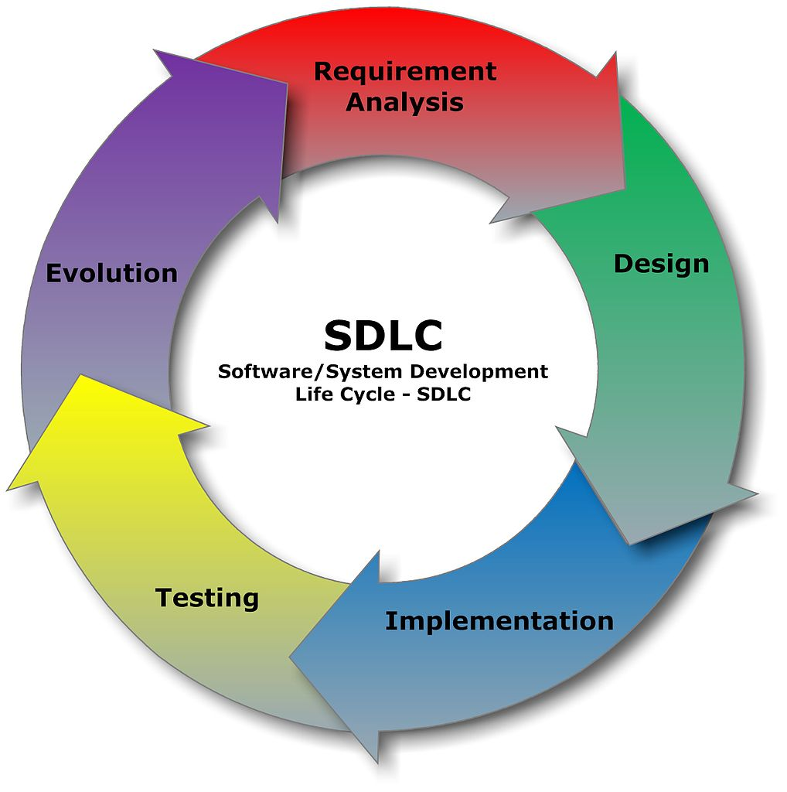

This Document is proprietary and confidential. No part of this document may be disclosed in any matter to a third party without permission from SeenPay.

INDEX

About the Team 1

Team Leader 1

Team Member 1

Channel of Communication 2

Download 2

Team Address 2

Team Channel 2

Recommend Developer Tool 3

Browser 3

Coding 3

Communication 3

Database 3

Design 3

Documentation 3

Networking 3

Server Hosting 3

Current mission 4

Proposal 5

Dell PowerEdge T20 Mini-tower Server System 5

What it use for? 5

Specification 7

Synology DiskStation DS214play 2-Bay NAS Server 8

What it use for? 8

Specification 9

Team Data Cloud Storage Explanation 11

Dropbox for Business 11

Getting Your Account 11

What does it use for? 11

Basic Feature 12

Google Drive 12

Getting Your Account 12

What does it use for? 13

Network Attachment Storage (NAS) 14

Getting Your Account 14

What does it use for? 14

Basic Feature (will be update) 15

Web Application Explanation 16

Interaction Diagram B2C 17

User Purchase Session 17

User Return Session 18

Server Application Explanation 19

Operating System 19

Database 19

Control Panel 19

Network Topology Explanation 20

Server Network 20

NAS Network 20

Database Explanation 21

Security Policy Explanation 22

Confidentiality, Integrity, and Availability Triad 22

What is it? 22

More Details and Explanation 22

Top 5 Layer of Information Security 25

Firewalls  25

Proxy Servers and Routers 26

Network Controls 27

Software Controls 27

Encryption 28

User Privilege Level 29

Maintenance Policy Explanation 30

Backup 30

Restore 30

Example Critical Event: 30

Server Hardware Explanation 31

Basic Information 31

# 

# About the Team

## Team Leader

**Zen Le**

IT Team Leader

Slack: #zenle311

## Team Member

**Huy Le**

Founder/Project Leader

Slack: #huyle

**Jimmy Vo**

Database and Hardware

Slack: #truongthinh1987

**Phuc Le**

IT Advisor

Slack: #phuclt2710

# Channel of Communication

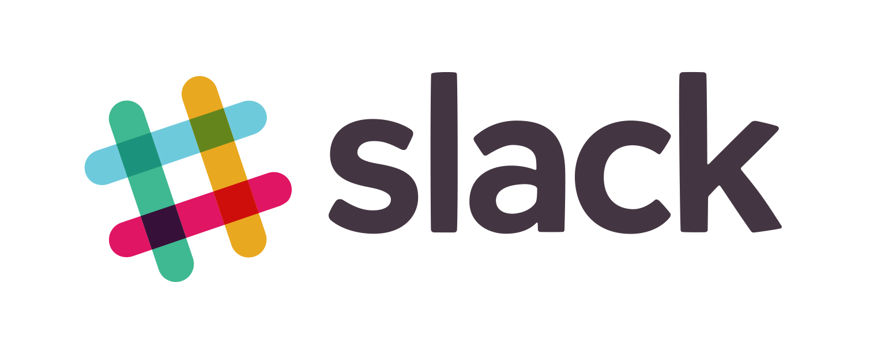

## Download

* **Apple AppStore**:  
  https://itunes.apple.com/au/app/slack/id803453959?mt=12
* **Google Play**:  
   https://play.google.com/store/apps/details?id=com.Slack&hl=en
* **Webpage**:

https://slack.com

## Team Address

SeenPay.com

## Team Channel

#tech-team

# Recommend Developer Tool

## Browser

* Google Chrome
* Apple Safari

## Coding

* Adobe Dreamweaver CS6 or above
* Notepad++
* PHPStorm

## Communication

* Slark Mobile Application
* Facebook Messenger
* Google Hangouts

## Database

* MySQL
* Microsoft SQL Server

## Design

* Adobe Photoshop CS6 or above
* Adobe Illustration
* JustInMind Prototype

## Documentation

* Microsoft Office 2003 or above

## Networking

* Cisco Packet Tracer

## Server Hosting

* Xampp Apache + MySQL + PHP + Perl (local hosting)

# Current mission

* Complete Interaction Diagram between B2C & C2C using Lucid Chart
* Complete Network Hardware planning
* Complete Network Topology using Diagram or Cisco Packet Tracer
* Complete Network Topology configuration in Cisco Packet Tracer

# Proposal

## Dell PowerEdge T20 Mini-tower Server System

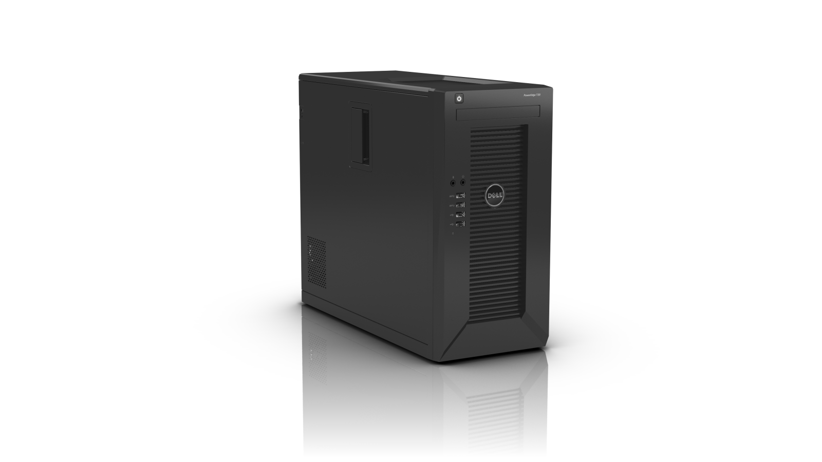

Overview

### What it use for?

* Webpage testing
* Hosting testing
* Intranet testing
* VPN testing
* Data Storage

## 

Back view

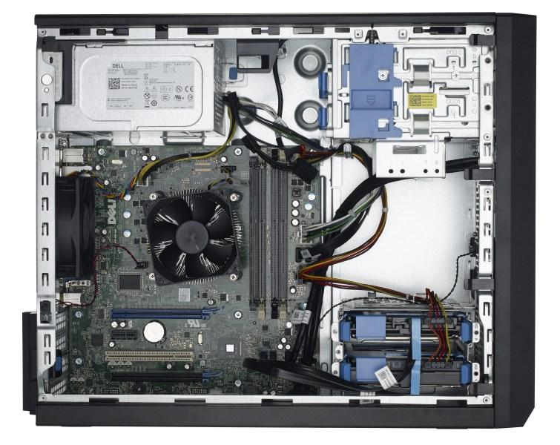

Side view

### Specification

#### MAIN

|  |  |
| --- | --- |
| Brand | DELL |
| Series | PowerEdge T20 |
| Model | 462-0993 |
| Type | Mini-tower |

#### PROCESSOR

|  |  |
| --- | --- |
| CPU Type | Intel Xeon E3-1225 v3 3.2GHz |
| Cache Memory | 8MB L3 Cache |
| CPU Features | Quad-core Processor  Max Turbo Frequency 3.6GHz |
| MAX Processors | 1 |

#### MEMORY

|  |  |
| --- | --- |
| Installed Memory Type | 2 x 4GB |
| Memory Type | DDR3 1600 |
| Memory Features | Dual Ranked UDIMM |

#### STORAGE

|  |  |
| --- | --- |
| Hard Drive (Installed) | 2 x 1TB 7200RPM |
| Storage Controller | Onboard SATA, HDD connected to onboard SATA Controller |
| HDD Interface | SATA |
| Raid Level | No RAID |
| Media Drives | No Internal Optical Drive |

#### EXPANSION

|  |  |
| --- | --- |
| Other Ports | Up to 12 USB (four USB 3.0) ports |

#### SOFTWARE

|  |  |
| --- | --- |
| Software | No |

#### FEATURES

|  |  |
| --- | --- |
| Features | 1 Year Basic Hardware Warranty Repair: 5x10 HW-Only, 5x10 NBD Parts |

Estimate Price: 667.48 USD*

*\*base on dell.com*

## Synology DiskStation DS214play 2-Bay NAS Server

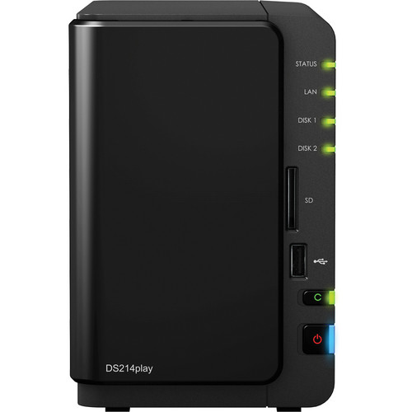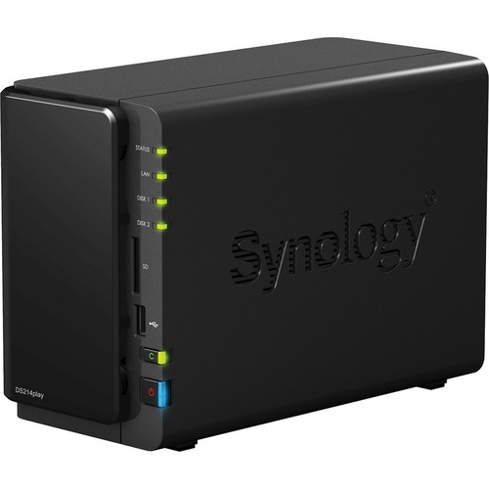

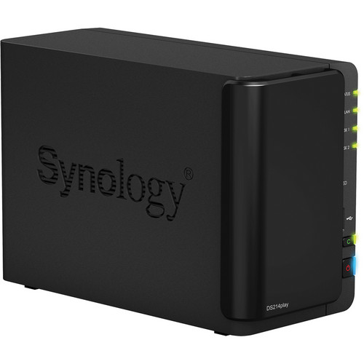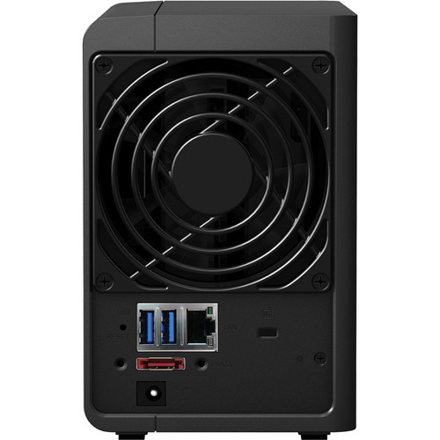

### What it use for?

* Cloud Data Testing
* Automatic Backup testing
* Data Storage

### Specification

#### Hardware Specification

|  |  |
| --- | --- |
| CPU Frequency | Dual Core 1.6 GHz |
| Floating Point | Yes |
| Hardware Transcoder | H.264 (AVC), MPEG-4 Part 2, MPEG-2, VC-1 |

#### Memory

|  |  |
| --- | --- |
| System Memory | 1 GB DDR3 |

#### Storage

|  |  |
| --- | --- |
| Drive Bays | 2 |
| Drive Type | 3.5" SATA(III) / SATA(II) HDD  2.5" SATA(III) / SATA(II) HDD  2.5" SATA(III) / SATA(II) SSD |
| Max Internal Capacity | 12 TB (6 TB HDD X 2) (Capacity may vary by RAID types) |
| Hot Swap Support | Yes |

#### External Ports

|  |  |
| --- | --- |
| USB 2.0 Port | 1 |
| USB 3.0 Port | 2 |
| eSATA Port | 1 |
| LAN Ports | 1 x Gigabit LAN (RJ45) port |
| SD Card Slot | Yes |
| USB/SD Copy | Yes |

#### File System

|  |  |
| --- | --- |
| Internal Drives | EXT4 |
| External Drives | EXT4, EXT3, FAT, NTFS, HFS+ |

#### Other Specification

|  |  |
| --- | --- |
| Wake on LAN/WAN | Yes |
| System Fan | 1 x fan (92 x 92 mm) |
| Wireless Support | Yes (with optional wireless dongle) |
| Noise Level | 19.8 dB(A) |
| Power Recovery | Yes |
| Power Supply | 65 W |
| AC Input Power Voltage | 100 V to 240 V AC |
| Power Frequency | 50/60 HZ, single phase |
| Power Consumption | 28.74 W (Access)  11.5 W (HDD hibernation) |
| Certifications | FCC Class B, CE Class B, BSMI Class B |
| Storage Management | Max File System Size: 16 TB  Max Internal Volume Number: 256  Max iSCSI Target Number: 10  Max iSCSI LUN: 10  Supported RAID Type: Synology Hybrid RAID, Basic, JBOD, RAID 0, RAID 1 |
| RAID Level Migration | Basic to RAID 1 |
| Volume Expansion | With Larger HDDs: Synology Hybrid RAID, RAID 1  By Adding a HDD: Synology Hybrid RAID |
| File Sharing Capacity | Max User Accounts: 2,048  Max Groups: 256  Max Shared Folder: 256  Max Shared Folder Sync Tasks: 4  Max Concurrent CIFS/AFP/FTP Connections: 256  Windows Access Control List (ACL) Integration |
| Dimensions (HxWxD) | 6.5 x 4.3 x 9.2" / 165 x 108 x 233.2 mm |
| Weight | 2.789 lb / 1.265 kg |

#### Environment Conditions

|  |  |
| --- | --- |
| Operating Temperature | 40 to 95°F / 5 to 35°C |
| Storage Temperature | 15 to 155°F / -10 to 70°C |
| Relative Humidity | 5 to 95% |
| Maximum Operating Altitude | 6,500 ft / 1,981 m |
| RoHS Compliant | Yes |

Estimate Price: 359.94 USD*

*\*Base on bhphotovideo.com*

# Team Data Cloud Storage Explanation

## Dropbox for Business

This will be main *cloud storage system* for the IT Department. Each IT members will have their own User Account.

### Getting Your Account

Please contact IT Department or your Team Leader for account information.

#### Marketing & Business Department

**Huy Le**

Founder/Project Leader

Slack: #huyle

#### IT Department:

**Zen Le**

IT Team Leader

Slack: #zenle311

### What does it use for?

Mostly *reports* and ***non-classified*** files

Example:

* Marketing Report
* User Growing Report
* Webpage template
* Coding irrelevant to page function (PHP, HTML, CSS, ASP.NET…)

### Basic Feature

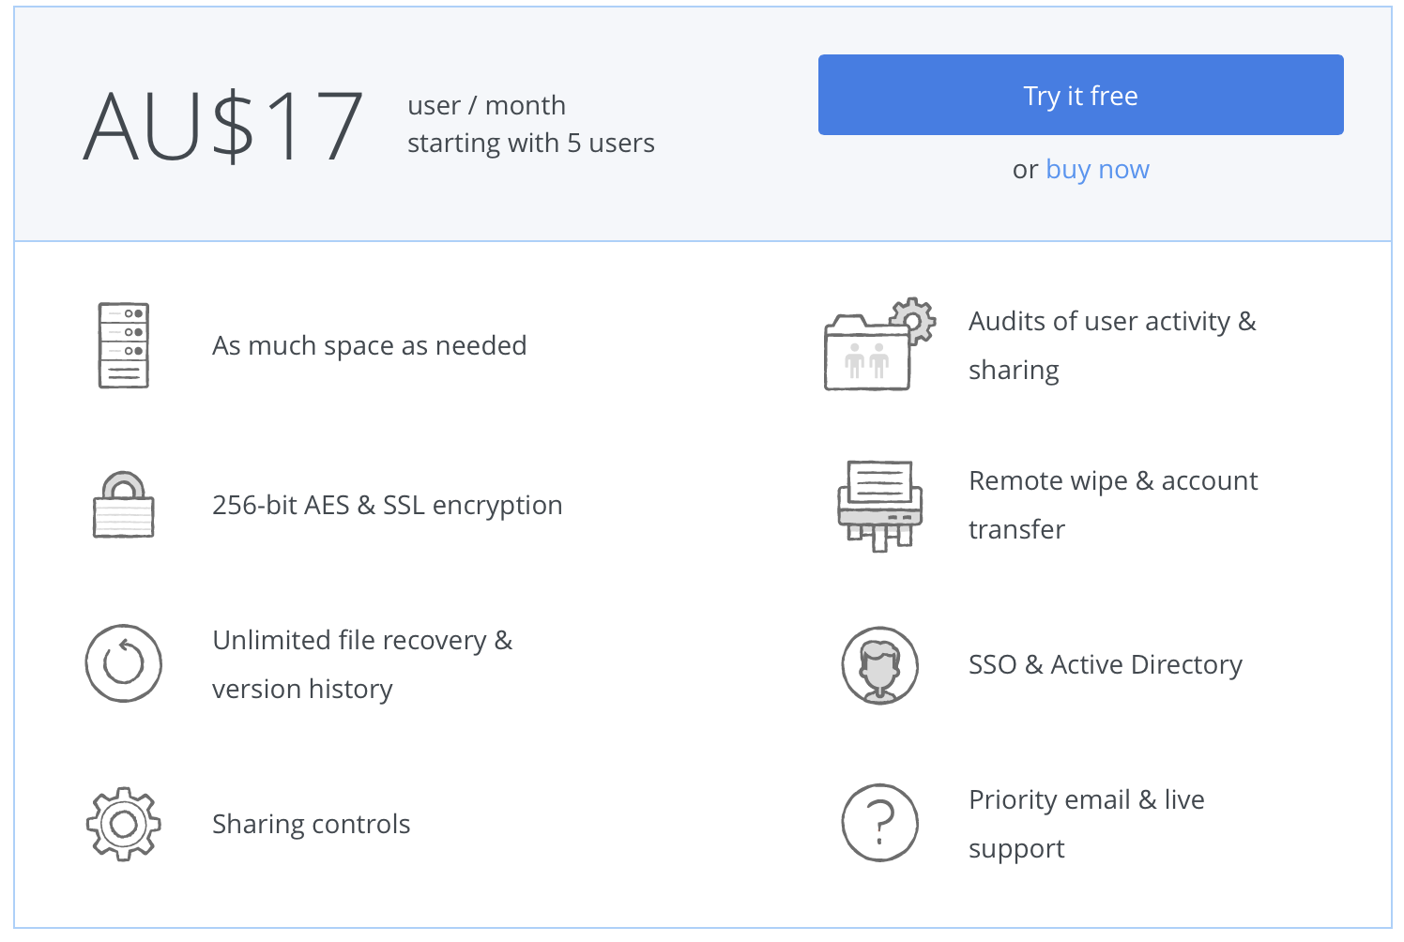

* Each user will have 1TB (1000 GB) of storage
* Dropbox offer 256-AES & SSL Encryption to ensure data protection and privacy
* File history will help to recover accidentally deleted files or modified files
* Dropbox will offer features to share file control (Read/Write/Execute)
* User action will be log with Dropbox activity log
* Data of user can be Remote Wipe and can transfer to another account
* SSO (Single Sign On) will make user only need to sign in one single time.
* Active Directory is a directory service that helps System determined whether login user is system administrator or normal user
* Live Support with Dropbox will be available with priority

## Google Drive

A second base storage system in case Dropbox has problems

### Getting Your Account

Please contact IT Department or your Team Leader for account information.

#### Marketing & Business Department

**Huy Le**

Founder/Project Leader

Slack: #huyle

#### IT Department:

**Zen Le**

IT Team Leader

Slack: #zenle311

### What does it use for?

Mostly *reports* and ***non-classified*** files.

Furthermore, please make a backup of your important documents on Dropbox weekly using Google Drive to ensure 100% data availability.

Example:

* Marketing Report
* User Growing Report
* Webpage template
* Coding irrelevant to page function (PHP, HTML, CSS, ASP.NET…)

## Network Attachment Storage (NAS)

This will be the second ***local and cloud storage system*** for Project members.

### Getting Your Account

Please contact IT Department or your Team Leader for account information.

*Please acknowledge that very few people have access to the NAS System as it contents top confidential files that will not affect working experiences of other members.*

#### Marketing & Business Department

**Huy Le**

Founder/Project Leader

Slack: #huyle

#### IT Department:

**Zen Le**

IT Team Leader

Slack: #zenle311

### What does it use for?

This will be used to store *backups*, *coding* and *data* that need **a very high level of confidential**. (TOP SECRET)

Example:(will be updated)

* User Login Database.
* User Banking Database.
* System Architecture Details.
* All data and coding that relevant to interaction between Bank system and SeenPay system.
* Security System Details.
* Security Bug Reports.
* Web Application bugs and Patches.

### Basic Feature (will be updated)

* Windows Server 2012
* ~12TB of Storage
* Dedicated high-speed fibre cable
* Active Directory
* Folder Sharing and Permission
* Auto Backup
* Using RAID 1+0

# Web Application Explanation

## Interaction Diagram B2C

### User Purchase Session

## Macintosh HD:Users:zenle:Google Drive:user purchase session.png

### User Return Session

### Macintosh HD:Users:zenle:Google Drive:user return session.png

# Server Application Explanation

## Operating System

Windows Server 2012 R2 Standard Edition

## Database

Microsoft SQL Server 2012

## Control Panel

Windows 2012 R2 STD Plesk 12

ISPconfig3

DirectAdmin

# Network Topology Explanation

## Server Network

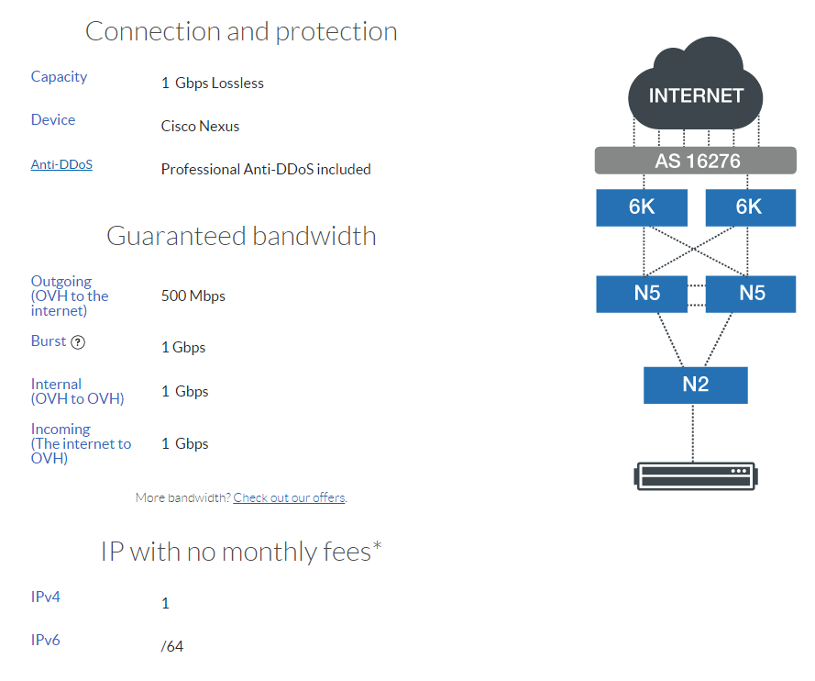

## NAS Network

# Database Explanation

(to be updated)

# Security Policy Explanation

## Confidentiality, Integrity, and Availability Triad

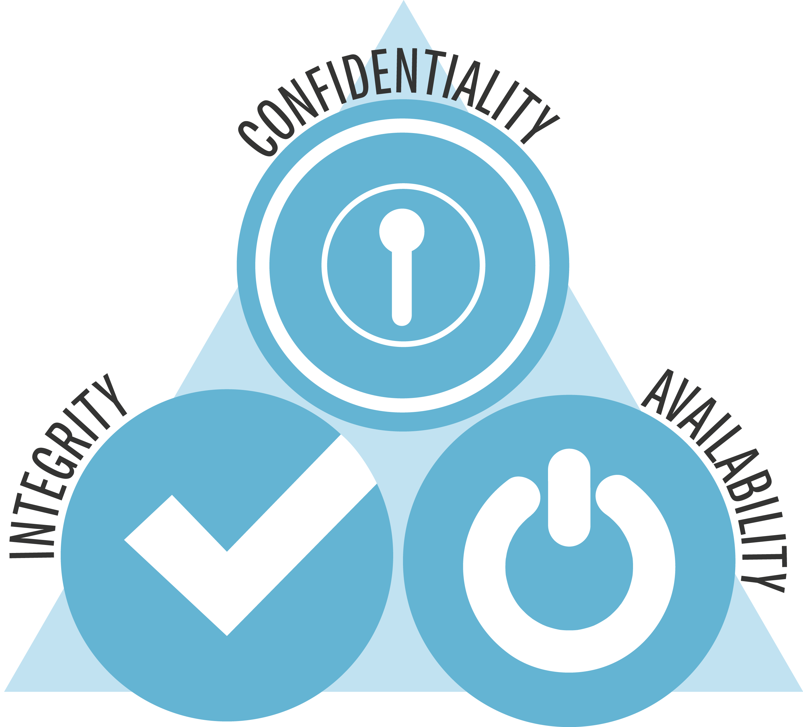 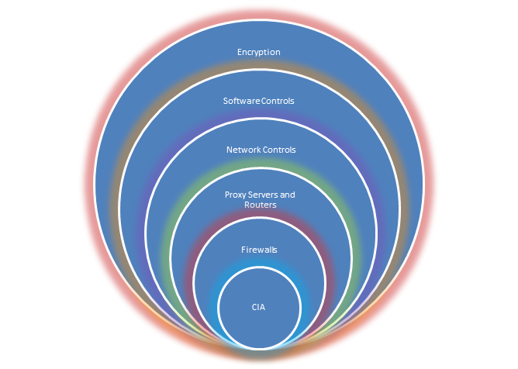

### What is it?

This is one of a basic Internet security knowledge. **C**onfidentiality, **I**ntegrity, and **A**vailability or also known as CIA.

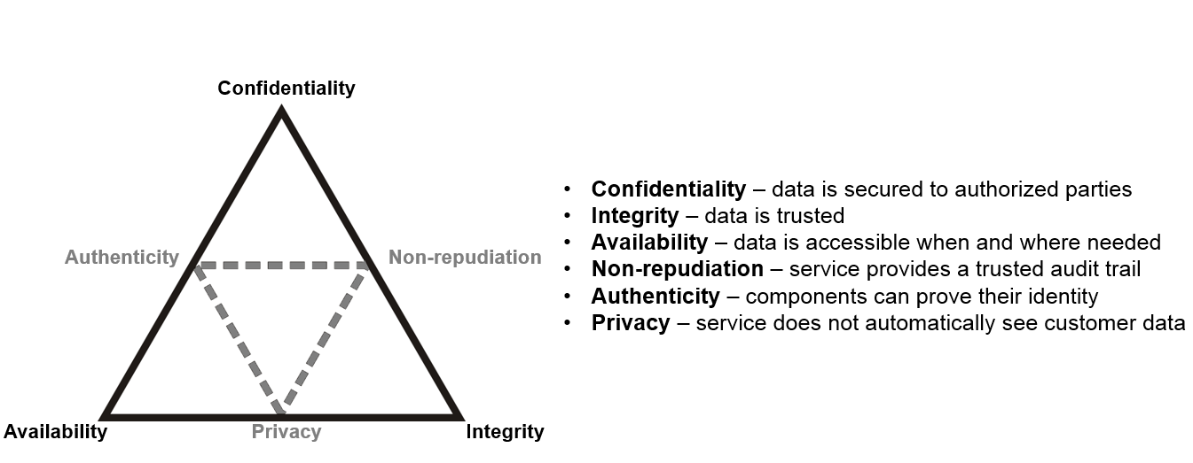

* Confidentiality is a set of rules that limits access to information.
* Integrity is the assurance that the information is trustworthy and accurate.
* Availability is a guarantee of reliable access to the information by authorized people.

### More Details and Explanation

*Adopted from: http://whatis.techtarget.com/definition/Confidentiality-integrity-and-availability-CIA*

#### Confidentiality:

Confidentiality is roughly equivalent to privacy. Measures undertaken to ensure confidentiality are designed to prevent sensitive information from reaching the wrong people, while making sure that the right people can in fact get it: Access must be restricted to those authorized to view the data in question. It is common, as well, for data to be categorized according to the amount and type of damage that could be done should it fall into unintended hands. More or less stringent measures can then be implemented according to those categories.

Sometimes safeguarding data confidentiality may involve special training for those privy to such documents. Such training would typically include security risks that could threaten this information. Training can help familiarize authorized people with risk factors and how to guard against them. Further aspects of training can include strong passwords and password-related best practices and information about social engineering methods, to prevent them from bending data-handling rules with good intentions and potentially disastrous results.

A good example of methods used to ensure confidentiality is an account number or routing number when banking online. Data encryption is a common method of ensuring confidentiality. User IDs and passwords constitute a standard procedure; two-factor authentication is becoming the norm. Other options include biometric verification and security tokens, key fobs or soft tokens. In addition, users can take precautions to minimize the number of places where the information appears and the number of times it is actually transmitted to complete a required transaction. Extra measures might be taken in the case of extremely sensitive documents, precautions such as storing only on air gapped computers, disconnected storage devices or, for highly sensitive information, in hard copy form only.

#### Integrity:

Integrity involves maintaining the consistency, accuracy, and trustworthiness of data over its entire life cycle. Data must not be changed in transit, and steps must be taken to ensure that data cannot be altered by unauthorized people (for example, in a breach of confidentiality). These measures include file permissions and user access controls. Version control maybe used to prevent erroneous changes or accidental deletion by authorized users becoming a problem. In addition, some means must be in place to detect any changes in data that might occur as a result of non-human-caused events such as an electromagnetic pulse (EMP) or server crash. Some data might include checksums, even cryptographic checksums, for verification of integrity. Backups or redundancies must be available to restore the affected data to its correct state.

#### Availability:

Availability is best ensured by rigorously maintaining all hardware, performing hardware repairs immediately when needed and maintaining a correctly functioning operating system environment that is free of software conflicts. It’s also important to keep current with all necessary system upgrades. Providing adequate communication bandwidth and preventing the occurrence of bottlenecks are equally important. Redundancy, failover, RAID even high-availability clusters can mitigate serious consequences when hardware issues do occur. Fast and adaptive disaster recovery is essential for the worst case scenarios; that capacity is reliant on the existence of a comprehensive disaster recovery plan (DRP). Safeguards against data loss or interruptions in connections must include unpredictable events such as natural disasters and fire. To prevent data loss from such occurrences, a backup copy may be stored in a geographically-isolated location, perhaps even in a fireproof, waterproof safe. Extra security equipment or software such as firewalls and proxy servers can guard against downtime and unreachable data due to malicious actions such as denial-of-service (DoS) attacks and network intrusions.

## Top 5 Layer of Information Security

*Adopted from: http://resources.infosecinstitute.com/guiding-principles-in-information-security/*

Information security is a protection mechanism. It starts with physical security and goes up to software and network security. By protecting the source of information at different levels, security administrators are able to develop a complete defensive model for the organization.

### Firewalls

Hardware firewalls are appliances used to keep programs from entering the network. A firewall uses access lists, which are summaries of networks that have or do not have access to the system. For example, a network with an IP address of 150.31.x.x may be allowed in, but all other networks may be denied entrance into the network. Hardware firewalls also can be used to set up VPNs and free servers for other duties.

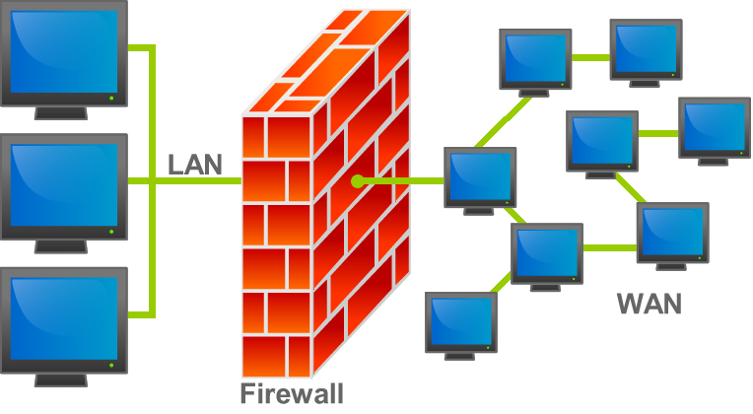

### Proxy Servers and Routers

Two other hardware devices can control information security for an organization. A server, via hardware such as a proxy server (pretending to be something else) can control what the outside world sees of the network. Since the Internet is an open system, anyone can have access to any device that has connections and access. So one way that protection comes about is by putting up a "smoke screen" on the network. That would be the proxy server. It hides the real network, by showing a minimal connection to the Internet.

A router is a different device that can control access to the network. Like a firewall, it can have access lists that allow or prevent access into a network. They are like a firewall; however, they do more than just monitor access: They route IP packets to other networks. No other device on the network or the Internet does that.

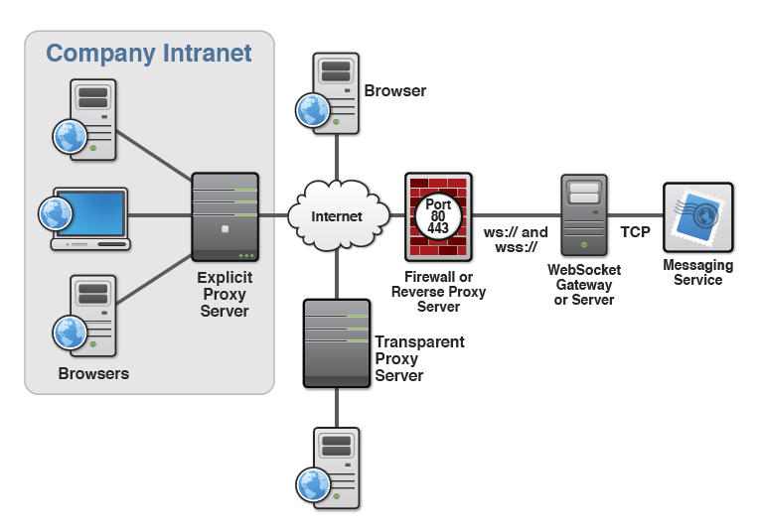

Both of these devices work to control access into the network, one direct (the router) and the other indirect (proxy server).

### Network Controls

Network controls can provide information security for an organization. This type of control occurs at the local level. Authentication involving logins and passwords are key. Every user must have an account that allows him to access the network.

Furthermore, the user must have a password, structured with a sophisticated protocol, like a minimum of ten characters, no common names, like "password," and a combination of letters and numbers. These network controls can affirm that only legitimate users will gain entrance to the network.

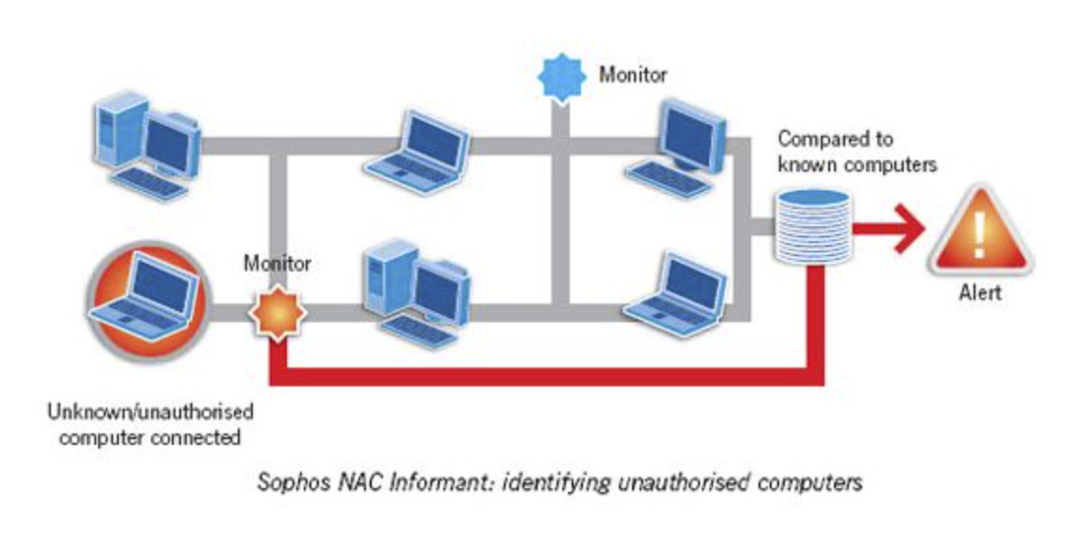

### Software Controls

Software Controls add another layer to information security by preventing viruses, spam, and other forms of malware from penetrating the system. If penetration does occur, then the controls should remove the infections and return the system to the pre-infestation state.

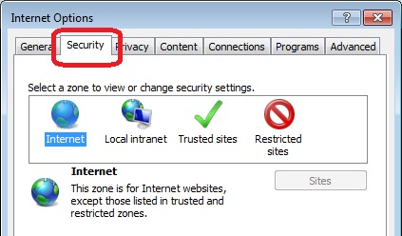

### Encryption

The final layer of security information is encryption. This involves changing the characters of a file to make them unreadable unless a key to decipher the information is available.

Encryption comes in different formats as encryption tools have become more sophisticated. There is manual encryption, which uses software, and a user must initiate the encryption. Transparent encryption occurs automatically without the user intervention.

Symmetric encryption occurs by using character substitution with a key that is used to decrypt the information. On the other hand, asymmetric encryption occurs when two keys are used, a public and a private. Anyone can encrypt using the public key, but only the person with the private key can decrypt the information.

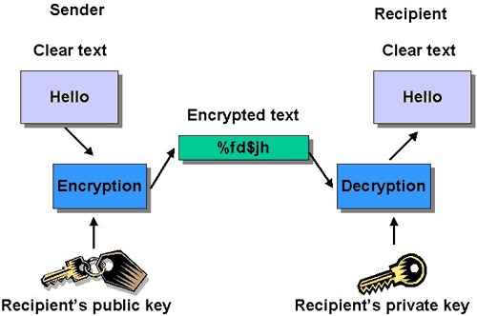

## User Privilege Level

# Macintosh HD:Users:zenle:Google Drive:user privilege.pngMaintenance Policy Explanation

(to be updated)

## Backup

Backup will be automatically done at the end of each day at 0:00 (GMT +7).

Backup will use a Dedicated Device/Disk (NAS or Hard Disk Drives)

## Restore

Restore will only use in ***critical event*** to avoid data losses.

### Example Critical Event:

* Data Loss (50GB or above).
* System Error (Fixing may take more than 2 day).
* Security Compromise (Administrator loss control of system).

# Server Hardware Explanation

(to be updated)

## Basic Information

Link: https://www.ovh.com/us/dedicated-servers/range-2013/2013-SP-64-PLUS-3HD.xml

